25.13 Editors - Properties Editor - Materials Tab
Detailed table of content 2
Preface 5
Affected Renderer 5
Material header 5
Material List 5
Add Material Slot 6
Remove Material Slot 6
Materials Specials menu 6
Material data property 8
Edit Mode 8
Preview Panel 9
Flat, Sphere, Cube, etc. 9
Preview World 9
Surface Panel 9
Use Nodes 9
Volume Panel 10
Use Nodes 10
Displacement Panel 10
Use Nodes 10
Settings Panel - Eevee renderer 11
Backface Culling 11
Blend Mode 11
Shadow Mode 11
Show Backface 12
Screen Space Refraction 12
Subsurface Transluency 12
Settings Panel - Cycles renderer 12
Pass Index 12
Surface 12
Volume 13
Homogenous 13
Step rate 13
Material Library VX 13
Library Browser 14
New Library 14
Preview Window 14
Apply 14
Preview 14
Materials List 14
Add to Library 14
Reload Material 15
Remove Preview 15
Remove Material 15
Settings 15
Search 15
Category Tools: 15
Viewport Display 16
Settings 16
Backface Culling 16
Blend Mode 16
Shadow Mode 17
Show Backface 17
Screen Space Refraction 17
Subsurface Transluency 17

Detailed table of content

Detailed table of content
Detailed table of content 2
Preface 5
Affected Renderer 5
Material header 5
Material List 5
Show in ghosts 6
Hide 6
Locked 6
Drag Handler 6
Search Field 6
Sort by Name 6
Reverse 6
Add Material Slot 6
Remove Material Slot 6
Materials Specials menu 6
With a mesh or curve or other object type 6
Copy Material 6
Copy Material to selected 7
Paste Material 7
Remove Unused Slots 7
With a grease pencil stroke object 7
Show All 7
Hide Others 7
Lock All 7
Unlock All 7
Lock Unused 7
Remove Unused Slots 7
Merge Similar 7
Convert Materials ot Vertex Colors 7
Extract Palette from Vertex Color 7
Material data property 8
Material Browser 8
New 8
Name 8
Fake User 8
New 8
Remove 8
Link 8
Edit Mode 8
Workflow 8
Assign 8
Select 8
Deselect 9
Preview Panel 9
Flat, Sphere, Cube, etc. 9
Preview World 9
Surface Panel 9
Use Nodes 9
Use Nodes unticked with Eevee 9
Use Nodes unticked with Cycles 9
Use Nodes ticked 9
Volume Panel 10
Use Nodes 10
Displacement Panel 10
Use Nodes 10
Settings Panel - Eevee renderer 11
Backface Culling 11
Blend Mode 11
Opaque 11
Alpha Clip 11
Clip threshold 11
Alpha Hashed 11
Alpha Blend 11
Shadow Mode 11
None 11
Opaque 12
Alpha Clip 12
Clip threshold 12
Alpha Hashed 12
Show Backface 12
Screen Space Refraction 12
Refraction depth 12
Subsurface Transluency 12
Pass Index 12
Settings Panel - Cycles renderer 12
Pass Index 12
Surface 12
Multiple Importance 13
Transparent Shadows 13
Displacement 13
Volume 13
Sampling 13
Interpolation 13
Homogenous 13
Step rate 13
Material Library VX 13
Library Browser 14
New Library 14
Preview Window 14
Apply 14
Preview 14
Materials List 14
Add to Library 14
Reload Material 15
Remove Preview 15
Remove Material 15
Settings 15
Force Import 15
Linked 15
Hide Search 15
Search 15
Category Tools: 15
Filter 15
Set Type 15
Add 15
Remove 15
Viewport Display 16
Settings 16
Backface Culling 16
Blend Mode 16
Opaque 16
Alpha Clip 16
Clip threshold 16
Alpha Hashed 16
Alpha Blend 16
Shadow Mode 17
None 17
Opaque 17
Alpha Clip 17
Clip threshold 17
Alpha Hashed 17
Show Backface 17
Screen Space Refraction 17
Refraction depth 17
Subsurface Transluency 17
Pass Index 17

Preface
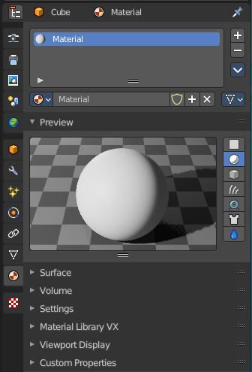
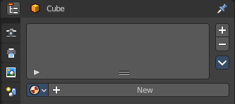
Materials controls the appearance of meshes, curves, volumes and other objects.

A material is the container that contains all the necessary data to define the look of an object. I is made of a code part, the shaders. They control how the surface reacts. And color data like textures. A black and white texture can also control what areas of a shader reacts in what way. Like a gloss map.

Materials can be created in either the Material properties, or in the Shader Editor. The content that is displayed is the same. But the way how it is represented is different.

Materials can be assigned to one or more objects, and different materials can be assigned to different parts of meshes.

The material system is built with physically-based rendering in mind. But can also be used to create toon style materials.

Affected Renderer
The material system is for Eeevee and Cycles. Workbench renderer is meant for fast preview display. It does not use materials like Eevee or Cycles. All you can choose is a color.
Eevee and Cycles have nearly the same nodes available. But some nodes differs. Eevee is a realtime renderer. Cycles is a physically based render. That's two different approaches. So you should take that into account when creating the materials.

Material header

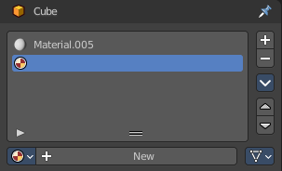
The header area contains the list of materials and the functionality to create new materials and to remove them.
A material for a mesh differs from a material for a grease pencil stroke.

Material List
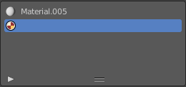
The list of assigned materials to this object. The list shows the material slots. A material slot that has the red material icon assigned has no material content yet. It is just an empty slot. You have to create it first by clicking at the New button below, in the material property.
Clicking at the name allows renaming of the material.
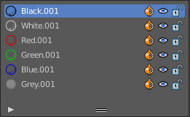
Grease pencil materials have additional functionality in the list.

Show in ghosts
Turn on onion skinning for this material. Onion skinning displays strokes before and after the current frame.

Hide
Show or hide the material.

Locked
Protect color from further editing.

Drag Handler
The two vertical lines at the end is a handler with which you can expand the list.

Search Field

You can expand a search field at the bottom of the list. Type in your term and hit enter to filter for your term.

Sort by Name
Sort the List by name.

Reverse
Exclude the search term instead of searching for it.

Add Material Slot
Add a new material slot

Remove Material Slot
Remove the selected material slot.

Materials Specials menu

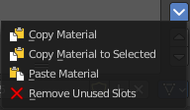
With a mesh or curve or other object type

Copy Material
Copy the material settings and nodes.

Copy Material to selected
Copy material to selected objects. First select the object without material. Hold down shift and select the object with material. Perform Copy material to selected.

Paste Material
Pastes a copied material.

Remove Unused Slots
Remove material slots that does not contain a material.

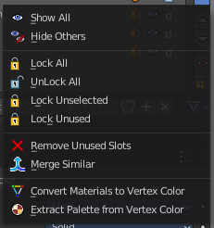
With a grease pencil stroke object

Show All
Show all materials.

Hide Others
Hide unselected materials.

Lock All
Lock all materials from editing.

Unlock All
Unlock all materials.

Lock Unused
Lock unused materials from editing.

Remove Unused Slots
Remove material slots that does not contain a material.

Merge Similar
Merge similar materials in stroke.

Convert Materials ot Vertex Colors
Grease pencil strokes can have either vertex colors or material colors. This feature converts the selected materials to a vertex color palette.

Extract Palette from Vertex Color
Grease pencil strokes can have either vertex colors or material colors. This feature converts a vertex color palette to materials.

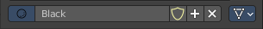
Material data property

Material Browser
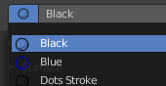
A list of the available materials in the scene where you can choose a material from.

New
When the object has no material yet. Creates a new default material and adds a first material slot to the list.

Name
The name of the active material. Double clicking allows to rename it.

Fake User
Keep this data even when it has no user in the scene.

New
Creates a new default material, and assigns it to the active material slot.

Remove

Link
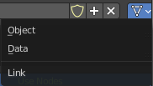
Specifies whether the material is to be linked to the Object or to the Object Data.
Different objects may share the same mesh data. And if the material is linked to the mesh, every object will share it. If the material is linked directly to the object data, the objects can have different materials and still share the same mesh. Default is Data.

Edit Mode
In Edit mode you can assign different materials at different mesh or curve parts.

Workflow
Enter Edit Mode. Select the material that you want to assign. Select the mesh or curve part. Click at the assign button.

Assign
Assign active material slot and material to the selected faces in the mesh, strokes in a Grease Pencil, and similar for other object types.

Select
Select faces assigned to the active material slot.

Deselect
Deselect faces assigned to the active material slot.

Preview Panel

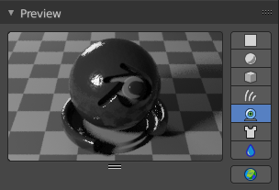
A preview window to judge the material.

Flat, Sphere, Cube, etc.
Different shaped preview objects.

Preview World
Include the world settings into the preview rendering.

Surface Panel

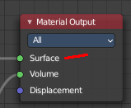
This panel displays the Surface part of the material as a list. And allows you to edit its values.

Use Nodes
Choose if you want to use nodes or not. Unticked it will use a default material with just basic values. Ticked it will use the material as defined in the shader editor in the Shading workspace. And display its values.
The values with unticked Use Nodes will not appear in the material node editor.

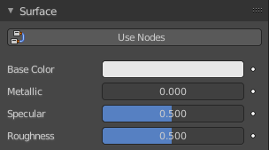
Use Nodes unticked with Eevee
Gives you the values for a very basic PBR realtime shader.

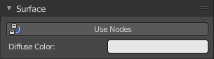
Use Nodes unticked with Cycles
Gives you a base color.

Use Nodes ticked
Displays the content of the material in the shader editor as a list.
Triangle buttons indicates that there is a node connected to this input. You can expand this triangle to access the values of the connected node.
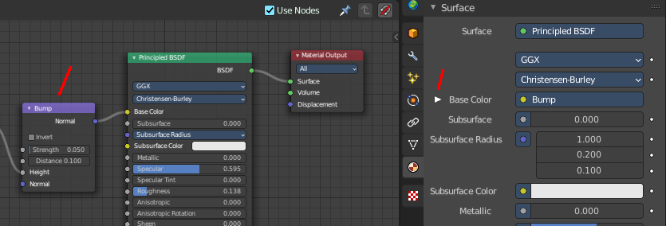

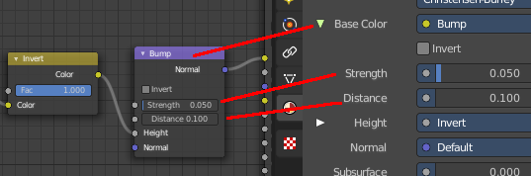

For the nodes and the values please have a look in the shader editor.

Volume Panel

This panel displays the Volume part of the material as a list. And allows you to edit its values.

Use Nodes
Choose if you want to use a volume node or not.
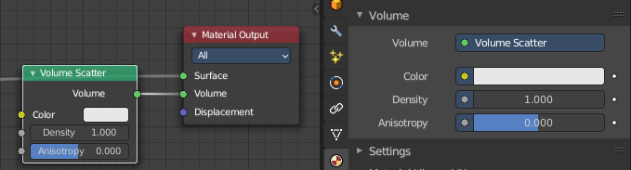

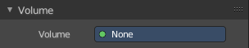
Removing the volume node in the shader editor will clear the volume panel.

Displacement Panel

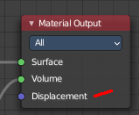
This panel displays the Displacement part of the material as a list.And allows you to edit its values.

Use Nodes
Choose if you want to use a displacement node or not.
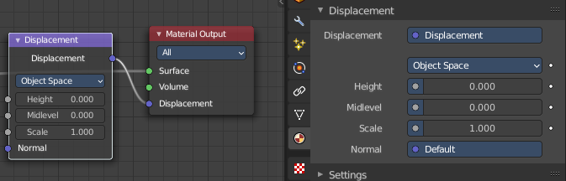

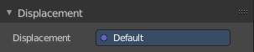
Removing th edisplacement node in the shader editor will clear the panel.

Settings Panel - Eevee renderer
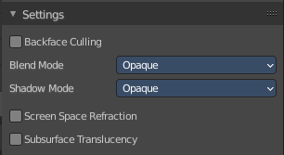

Backface Culling
Use back face culling to hide the back side of faces.

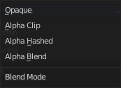
Blend Mode
The blend mode for transparent faces.

Opaque
Render surface without transparency.

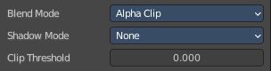
Alpha Clip
Use the alpha threshold to clip the visibility. On or off.

Clip threshold
A pixel is just rendered if the value is higher than this clip threshold. This threshold is the same for blend mode and shadow mode.

Alpha Hashed
Use Noise to dither the binary visibility. Works best with multi samples.

Alpha Blend
Render polygons transparent, dependant of the alpha channel of the texture.

Shadow Mode

None
Material will cast no shadow.

Opaque
Material will cast shadow without transparency.

Alpha Clip
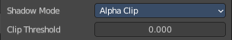
Use the alpha threshold to clip the visibility. On or off.

Clip threshold
A pixel is just rendered if the value is higher than this clip threshold. This threshold is the same for blend mode and shadow mode.

Alpha Hashed
Use Noise to dither the binary visibility.

Show Backface
With Blend Mode Alpha Blend. Limit the transparency to a single layer to avoid transparency layer sort problems.

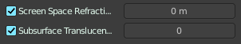
Screen Space Refraction
Use raytraced screen space refraction.

Refraction depth
The thickness of the object to compute two refraction event. 0 means disabled.

Subsurface Transluency
Add transluency effect to subsurface.

Pass Index
Index number for the material index render pass.

Settings Panel - Cycles renderer

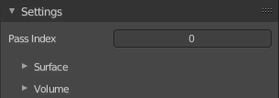
Material settings.

Pass Index
The index number of this material. This material index can be used for masking in post processing for example.

Surface
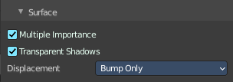
Surface related settings.

Multiple Importance
By default lights use only direct light sampling. Which can be noisy with sharp glossy reflections. Multiple Importance activates Indirect light sampling to reduce noise.

Transparent Shadows
Use transparent shadows if the material contains a transparent bsdf node.

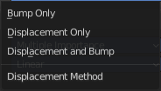
Displacement
What method to use for displacement.

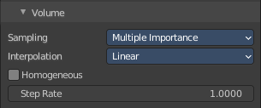
Volume

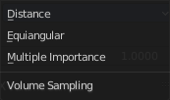
Sampling
What sampling method to use for volume rendering.

Interpolation
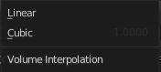
What interpolation method to use for volume rendering.

Homogenous
Assume to have a homogenous volume to speed up rendering.

Step rate
Scale the distance between volume shader samples when rendering the volume. Lower values increases accuracy and render time.
Step rate becomes disfunctional when Homogenous is activated.

Material Library VX

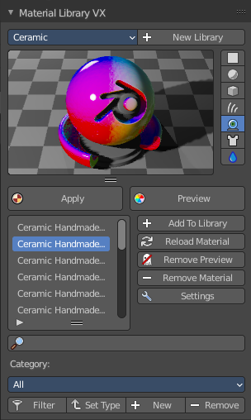
Materials Library VX is a Blender material library add-on. You can save, load and categorize materials that can be shared across all your projects.

It’s advisable to add a Fake User to your materials and to save your blend-file before use.

Note that this addon creates a material_preview_dummy object to allow the material preview.
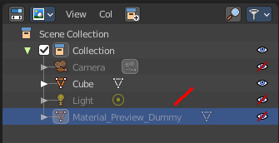

Library Browser
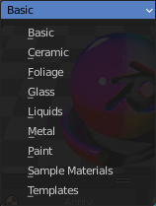
A list of the avaiable libraries. Switching to another library will load it.

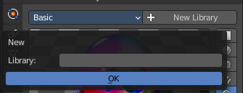
New Library
Create a new Library and name it. The new library will have one material to start.

Preview Window
A material preview window.

Apply
Apply the currently selected material to the object. Note, sometimes the object gets deselected. And then you get a warning. Simply select the object, and try again.

Preview
The material can be previewed before you assign it. Preview will also refresh the material preview window. It is not updated by choosing another material.

Materials List
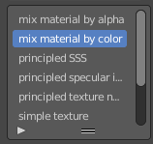
The list of the available materials in this library. Choose a material, click at the Preview button to preview it in the preview window. Click at the Apply button to assign the material to the selected object.

Add to Library
Add your materials to the library.

Reload Material
Restore the saved version of the material if you want to revert edits.

Remove Preview
Restore the Preview panel.

Remove Material
Delete the active material from the Matlib VX list and your library.

Settings
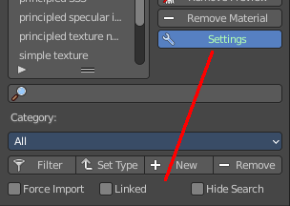
Options. They appear at the end.

Force Import
Use Scene Materials by default.

Linked
Link the material instead of append it.

Hide Search
Hides the search field.

Search
Search the library for a material.

Category Tools:
Here you can make sub categories.

Note, this part is simply broken. Don't even bother.

Filter
Apply the current filter.

Set Type
Apply the current selected category to the current material library.

Add
Add a new category.

Remove
Remove the current selected category from the list.

Viewport Display

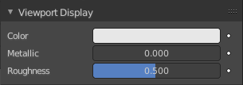
Display settings for viewport display mode Solid. The items should be self explaining.

Settings
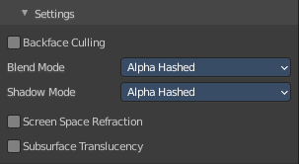
Cycles only. And with Cycles these settings are just relevant for the viewport rendering in Material Preview mode. That's why they are in the viewport display panel.
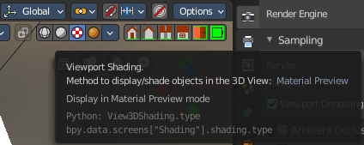

Backface Culling
Use back face culling to hide the back side of faces.

Blend Mode
The blend mode for transparent faces.

Opaque
Render surface without transparency.

Alpha Clip
Use the alpha threshold to clip the visibility. On or off.

Clip threshold
A pixel is just rendered if the value is higher than this clip threshold. This threshold is the same for blend mode and shadow mode.

Alpha Hashed
Use Noise to dither the binary visibility. Works best with multi samples.

Alpha Blend
Render polygons transparent, dependant of the alpha channel of the texture.

Shadow Mode

None
Material will cast no shadow.

Opaque
Material will cast shadow without transparency.

Alpha Clip
Use the alpha threshold to clip the visibility. On or off.

Clip threshold
A pixel is just rendered if the value is higher than this clip threshold. This threshold is the same for blend mode and shadow mode.

Alpha Hashed
Use Noise to dither the binary visibility.

Show Backface
With Blend Mode Alpha Blend. Limit the transparency to a single layer to avoid transparency layer sort problems.

Screen Space Refraction
Use raytraced screen space refraction.

Refraction depth
The thickness of the object to compute two refraction event. 0 means disabled.

Subsurface Transluency
Add transluency effect to subsurface.

Pass Index
Index number for the material index render pass.

